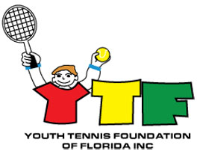

GUIDELINES FOR
YTF JOHN VAN RYN SCHOLARSHIP
www.YTF-FL.org

- College student

- Positive attitude

- Enthusiastic to learning

- Commitment to helping others learn tennis

5. Service to community

A financial scholarship of $1000 will be directed to the recipient’s educational institution to assist with educational expenses.

Please submit application to:

Youth Tennis Foundation
c/o Pierce Kelley
- O. Box 452
Fort White, FL 32038
OR
Email piercekelley@att.net

Apply starting July 1 of the current year
Winner to be chosen by YTF board
Winner will be notified by Pierce Kelley

Application Form
YTF John Van Ryn Scholarship
www.YTF-FL.org

NAME:

ADDRESS:

PHONE NUMBER:

EMAIL ADDRESS:

COLLEGE ATTENDING:

REFERENCE CONTACT INFO:

Why do you feel you qualify for the YTF John Van Ryn Scholarship?

(attach additional sheet if necessary)

Recommendation from reference:

(attach additional sheet if necessary)

Please send completed application to

Youth Tennis Foundation
c/o Pierce Kelley
- O. Box 452
Fort White, FL 32038
OR
Email piercekelley@att.net

Visit YTF website, www.YTF-FL.org, for more information

